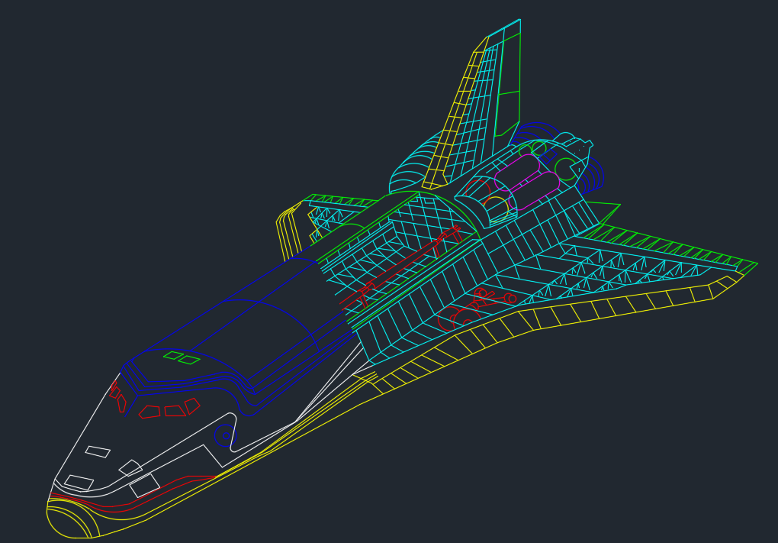A Brief History of Computer Graphics

•1950: The first graphic images are created by Ben Laposky using an oscilloscope to generate waveform artwork produced by manipulating the analog electronic beams.

1951: Designed to support military preparedness, Jay Forrester and Robert Everett of the Massachusetts Institute of Technology (MIT) produce the Whirlwind, a mainframe computer with a CRT to plot blips representing incoming aircrafts based on radar-gathered data.

• 1955: Direct descendant of the Whirlwind, the SAGE (SemiAutomatic Ground Equipment) air defense system is designed by Bert Sutherland at MIT. It uses simple vector graphics to display on analog CRTs radar images with a wireframe outline of the region being scanned, as well as the first light pen as an input device that operators would use to pinpoint planes flying over regions of the United States. It becomes a key part of the US missile defense system.

• 1959: General Motors and IBM develop “DAC-1” (Design Augmented by Computers), the first industrial CAD system (Computer-Aided Design) used to help engineers design cars. It allows a user to rotate and view a simple drawings.

•1960: The term “computer graphics” is coined by William A. Fetter at Boeing to describe the new design methods for his human factors cockpit simulations. Two years later, he will create the “First Man” digital human for cockpit studies.

• 1961: Spacewar, the first video game, is developed by MIT student Steve Russell for the DEC PDP-1 minicomputer.

• 1963: For his doctoral thesis at MIT, Ivan Sutherland develops Sketchpad, the first Computer-Aided Drafting and Design (CADD) package allowing shapes to be interactively drawn on a vector-based display monitor using a light pen input device wired into the computer. The light pen uses a small photoelectric cell in its tip to emit an electronic pulse when the pen “sees” the electron beam.

• 1963: Larry Roberts develops the first effective hidden-line removal algorithm, the precursor to various subsequent hidden-line and hidden-surface algorithms.

• 1963: The mouse is invented by Doug Englebart at the Stanford Research Institute (SRI).

• 1965: The digital line drawing algorithm for raster devices developed in 1962 by Jack Bresenham at IBM is published.

• 1966: Ivan Sutherland creates the first head-mounted display, the Sword of Damocles, which displays separate wireframe images, allowing depth perception.

• 1967: MIT’s Center for Advanced Visual Studies is founded by Gyorgy Kepes.

• 1967: Don Greenberg starts a program at Cornell. • 1968: Dave Evans joins the computer science department at the University of Utah and forms a CG group. Sutherland also joins the University of Utah.

• 1968: Frustrated by the lack of graphics hardware available, Evans & Sutherland then found their own company.

• 1968: Intel is founded.

• 1968: Arthur Appel at IBM introduces ray-casting, a precursor to ray-tracing which combines a hidden-surface and shadow algorithm.

• 1969: Initiated by Sam Matsa and Andy vanDam, ACM creates a special interest group on graphics, SIGGRAPH. The first SIGGRAPH conference held in Boulder in 1973 counts 1,200 attendees versus about 20,000 nowadays.

• 1969: At the Palo Alto Research Center (PARC) of Xerox, Utah alumni Alan Kay develops the concept of Graphical User Interface (GUI).

• 1969: The first framebuffer (with 3 bits per pixel) is built at Bell Labs, initiating the transition from vector graphics, i.e. drawing lines between coordinates, to raster video displays containing a value for each pixel on the screen, transforming vector representations into raster format images.

• 1971: Gouraud shading is developed by Utah student Henri Gouraud. By interpolating intensity, visual improvements over flat shading may be achieved at a marginal cost.

• 1973: The entertainment feature film Westworld makes the first use of 2D animation, while 3D wireframe CGI will first be used 3 years later in its sequel Futureworld.

• 1974: Wolfgang Strasser in his dissertation describes the ZBuffer, together with Jose Encarnacao he can be seen as the fathers of CG in Germany • 1974: Utah student Edwin (Ed) Catmull (now president of Walt Disney Animation Studios) develops both the Z-buffer hidden-surface algorithm as well as texture mapping.

• 1974: Alexander (Alex) Schure, founder of the New York Institute of Technology (NYIT), creates a new Computer Graphics Lab, naming Ed Catmull director. Joined by Alvy Ray Smith and others, the team develops interest in producing what could have been the first feature-length CGI film, The Works, but it was never completed.

• 1975: Utah student Bui Tuong Phong develops a specular illumination model. He also introduces the interpolation of normals for shading, now known as Phong shading.

• 1975: At IBM, mathematician Benoit Mandelbrot introduces geometry of fractional dimension. Fractals are used in computer graphics to create realistic simulations of natural phenomena such as mountains, coastlines, wood grain…

• 1975: Using Bezier patches, Utah student Martin Newell creates a 3D computer model of a physical teapot, now at the Computer Museum in Boston. Serving as a benchmark throughout history, the Utah teapot has become an icon of 3D computer graphics.

• 1975: At the age of 19, William (Bill) Gates III dropped out of Harvard and founds Microsoft with his friend Paul Allen.

• 1976 : The CRAY-I Super Computer is introduced and becomes the standard for large-scale scientific computing.

• 1976: Steve Jobs and Steve Wozniak found Apple. After a visit of Xerox’s PARC in 1979, introducing the Macintosh in 1984 which will spark the graphical user interface revolution.

• 1977: Utah alumni Frank Crow develops solutions to the aliasing problem, i.e. anti-aliasing.

• 1977: The Academy of Motion Pictures Arts and Sciences introduces the category titled Visual Effects for the Oscars. The Best Animated Feature Film Award will then be approved in 2001.

• 1977: Utah student James (Jim) Blinn (now at Microsoft Research) presents a new illumination model that considers surface facets, and a year later, introduces bumpmapping.

• 1979: George Lucas hires Ed Catmull and many others from the NYIT, to form Lucasfilm’s CG team in San Rafael, CA.

• 1980: Turner Whitted at Bell Labs (now at Microsoft Research) introduces a general ray tracing paradigm which incorporates reflection, refraction, antialiasing, and shadows.

• 1980: The European Association for Computer Graphics is formed and the first EUROGRAPHICS conference held in Geneva.

• 1980: The MIT Media Lab is founded by Nicholas Negroponte.

• 1980: The computer animation production studios Pacific Data Images (PDI) is founded by Carl Rosendahl.

• 1981: After some work on fractals while at Boeing in 1980, Loren Carpenter is hired by Lucasfilm and, in collaboration with Cook and Catmull, writes their first renderer, called REYES (Renders Everything You Ever Saw). It included the RenderMan Shading Language (Pat Hanrahan, now Stanford) and would eventually turn into the Renderman rendering engine.

• 1981: IEEE Computer Society starts publishing a new journal, Computer Graphics and Applications.

• 1982: ACM starts publishing Transactions on Graphics TOG.

• 1982: Utah alumni James (Jim) Clark founds Silicon Graphics Inc. (SGI), a leader in producing low-end to high-end graphics workstations and supercomputers.

• 1982: After inventing the Postscript language, Utah alumni John Warnock founds Adobe Systems.

• 1982: Autodesk is founded and AutoCAD released.

• 1982: Lucasfilm computer graphics division develops a oneminute shot for Star Trek II: The Wrath of Khan making the first use of fractal-generated landscape in a film. William (Bill) Reeves leads the Genesis Effect programming team and creates the so-called Particle Systems.

• 1982: Disney releases Tron, the first film with 15 minutes of fully computer generated 3D shots including the famous Light Cycle sequence inside a videogame. The movie is now recognized as a landmark despite its box office failure.

• 1984: The first movie to use “integrated CGI” where the effects are supposed to represent real world objects is released. The Last Starfighter includes CG spaceships, planets, and high-tech hardware integrated into live-action scenes, but will also be a box office failure.

• 1984: Michael Cohen introduces the Cornell Box which will symbolize the approach to physically-based rendering.

• 1984: Based on heat transfer, Cindy Goral, Kenneth Torrance, Don Greenberg and Bennett Battaile at Cornell University introduce Radiosity, allowing realistic renderings.

• 1984: Part of Lucasfilm’s team, Cornell alumni Robert (Rob) Cook proposes an extended version of ray-tracing. Distribution ray-tracing allows the realistic simulation of motion blur, depth of field, soft shadows, etc…

• 1984: Lucasfilm’s computer animation division creates The Adventures of André and Wally B., the first all-CGI animated short film, followed by Pixar’s Luxo Jr. in 1985.

• 1985: Ken Perlin introduces noise functions as a means of creating natural patterns such as marble, wood, …

• 1986: Utah alumni James (Jim) Kajiya (now at Microsoft Research) introduces the Rendering Equation allowing realistic light inter-reflections to be path-traced.

• 1986: The computer graphics division of Lucasfilm splits off as a separate company focused on animated films, Pixar, headed by Ed Catmull and purchased by Steve Jobs.

• 1986: Industrial Light and Magic (ILM), the special effects division of Lucasfilm, starts a CGI group.

• 1986: Mental Images is founded in Berlin, bought by Nvidia in 2007.

• 1989: REYES-based Pixar’s RenderMan system is released and a year later its shading language by Jim Lawson and Pat Hanrahan.

• 1991: Although 3D computer graphics debuted in earlier in Disney productions, Beauty and the Beast is the first where hand-drawn characters appear with 3D animated objects.

• 1992: Silicon Graphics Inc. (SGI) releases the Open Graphics Library (OpenGL) specification defining a standard cross-language cross-platform API for computer graphics (now managed by Khronos, being replaced by Vulkan).

• 1993: Nvidia is founded, later attracts many engineers from SGI and other companies to become the main graphics HW company (besides ATI and Intel today).

• 1995: Pixar Animation Studios produce Toy Story, the first computer-animated full-length feature film, demonstrating the possibilities of CGI graphics in moviemaking.

• 1996: The 3D gaming industry sees a breakthrough with the release of Quake, lead by John Carmack at ID Software, which used actual 3-D models in a truly 3-D space.

• 2001: Although it fails commercially, Final Fantasy - The Spirits Within is the first feature-length digital film that includes a cast of photorealistic digital actors, stirring the imagination of the press and CG community. Raises awareness of the “uncanny valley”.

What Does Simulation Mean?

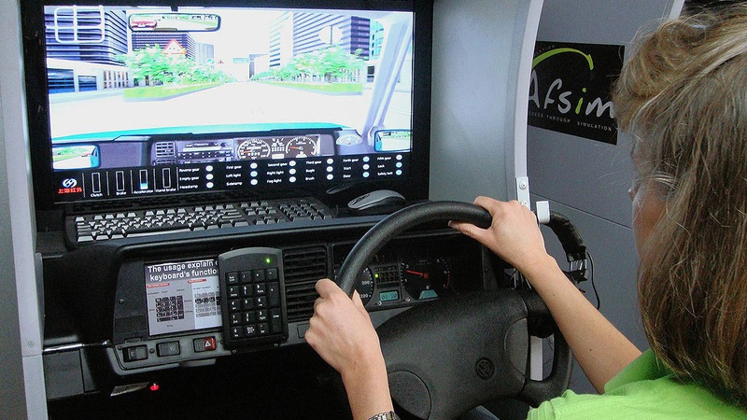

A simulation is any research or development project where researchers or developers create a model of some authentic phenomenon. Many aspects of the natural world can be transformed into mathematical models, and using simulation allows IT systems to mimic the outcomes that happen in the natural world.

A simulation is the imitation of the operation of a real-world process or system over time. Simulations require the use of models; the model represents the key characteristics or behaviours of the selected system or process, whereas the simulation represents the evolution of the model over time.

Simulation involves the reproduction or emulation of a given type of situation or experience. A simulation usually offers some form of ‘“safety net’” for the experience rather then being subjected to the full consequences of a ‘“live’” or real situation.

Simulation is defined as the process of creating a model of an existing or proposed system in order to identify and understand those factors which control the system and/or to predict the future behavior of the system.

In [computer science](https://en.wikipedia.org/wiki/Computer_science), simulation has some specialized meanings: [Alan Turing](https://en.wikipedia.org/wiki/Alan_Turing) used the term simulation to refer to what happens when a [universal machine](https://en.wikipedia.org/wiki/Universal_Turing_machine) executes a state transition table (in modern terminology, a computer runs a program) that describes the state transitions, inputs and outputs of a subject discrete-state machine.

A simulation is a model of a system. Also known as: reality model, similar to virtual model; associated in the manuscript with simulation games, learning simulations.

## Some of the application areas of simulation

### Logistics simulation:

Optimize complex and dynamic logistics processes with simulation

### Simulation in production:

Includes modeling single production lines, from the design of production resources and buffer sizes to the simulation of entire production plants

### Detailed production planning:

Optimization of preliminary planning while taking into account dynamic factors like current availabilities or disruptions, resources, inventories, filling level of the facility, etc.

### Emulation:

Virtual testing of control software with simulation

### Artificial Intelligence:

AI technology in use for process optimization in production and logistics

### Hospital Simulation:

Verification of processes and material flows in hospitals

### Planning of machine scheduling:

Optimising machine capacity utilization by minimizing set-up times and avoiding standby- and waiting times

### Control station simulation:

Optimisation of control strategies with the help of simulation

### Personnel simulation:

Assistance for personnel resource planning and personnel dispatching

### Supply Chain simulation:

Modeling and analysis of supply networks

* Military:
* Telecommunication

And many more..

## Advantages and Disadvantages of Simulation

Advantages

* Simulation is best suited to analyze complex and large practical problems when it is not possible to solve them through a mathematical method.
* Simulation is flexible, hence changes in the system variables can be made to select the best solution among the various alternatives.
* In simulation, the experiments are carried out with the model without disturbing the system.
* Policy decisions can be made much faster by knowing the options well in advance and by reducing the risk of experimenting in the real system.

Disadvantages

* Simulation does not generate optimal solutions.
* It may take a long time to develop a good simulation model.
* In certain cases simulation models can be very expensive.
* The decision-maker must provide all information (depending on the model) about the constraints and conditions for examination, as simulation does not give the answers by itself.

Prepared by Samuel Biniam. 🪐